**Team members:**

Ying Huang, Prutha Sinai Khandeparker, Liang Dong, Justin Smith, Viralkumar Sanghavi

**Objective**: Improve user experience on activategood.com  
**Tagline**: Happy volunteering!

**Approach**: We took a 3 step approach to meet final goal.

**Phase 1 - Understanding the problem space:**

We tried to understand why people volunteer and how they select volunteer opportunities. To achieve this, we conducted 15 preliminary interviews, asking questions about their volunteer motivation, recent experiences, way to involve and share. The analysis of interviews gave us good insight about different volunteer personalities like shepherd (Actively participates and encourages other to volunteer), follower (Participates in volunteering endorsed by others), lone wolf(more comfortable attending volunteer opportunities on her own)and many more. The main take away was to design user interface in a way that it attracts each personas.  
  
**Phase 2 - User research and analysis:**

We conducted a user study involving 15 people with different demographics to evaluate homepage and search functionalities. We did a screencast while users performed certain tasks on activategood.org. Also we measured net promoter rating before and after interview. Overall, it went up for 60% users, remained same for 20% and went down for 20% users. This user studies gave us very good insight of trouble experienced by users.

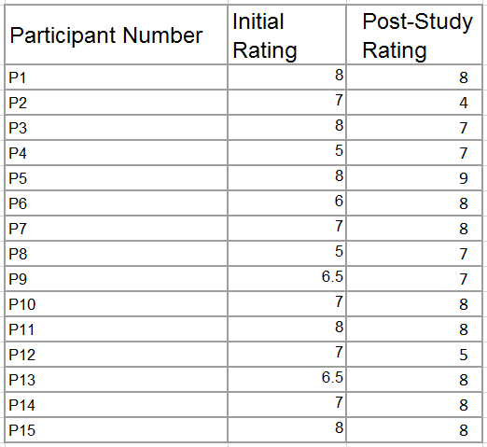

Table 1: net promoter rating before and after interview

There were many pain points related to design, usability and backend. Below is the broad list of issues identified in this phase:

* ***Home Page Design*** *-*Some participants thought the site was untrustworthy with the large ads. The two search related boxes were not grouped. Donate and mailing list out of context. Participant didn’t notice search box instead clicked for volunteers. Some felt content was crammed.
* ***Keyword/Cause Confusion*** *-* Participants thought keyword search and causes were too similar.
* ***Search efficiency*** *-* searching for *“*sport” gave no result while searching for “sports” gave results
* ***Search Returns Full Events***- Participants didn’t want to see events that had been

filled up already.

* ***Just in the Triangle***- Searching outside the triangle doesn’t return results. Should be an explicit warning. P5 kept searching in virginia or DC.
* ***Date Confusion*** *-* Some events outdated, some far in the future. Not clear when the event actually was.
* ***Separating Search Results*** *-* Not clear where one result started and the other ended.
* ***Inconsistent Event Descriptions***- Some descriptions contained dates and times others had some, but not all of that info
* ***Small Suff*** - Remove search filters, date pickers show span, pick multiple causes
* ***Sharing options*** - participants said they wanted to share the event through social media
* ***Displaying the search results in some order***- sorted by date/relevance etc.
* ***No Inbox for signing up***- Users don’t know whether their applications are approved or not, two activategood users complain about it.

**Phase 3 - Prototyping, development and evaluation**

In phase 3, we synthesized our observations from Phase 2 with user’s design recommendations in addition to our own intuitions about the site. This synthesis produced three mockups, which we hope the developers at activate good can use to guide the design of the future site. We decided to deliver mockups, because they allow for some flexibility in their interpretation. The designers of activate good may choose to adopt some of our suggestions and reject others. The mockups we created cover three distinct areas on the site, listed below:

**Homepage:** The redesigned homepage presents a simplified search box. The search box helps users discern between keywords and causes, an issue we observed in our user study. The date and location filters that comprise the rest of the search box now use more natural language. We reorganized the homepage to group elements more logically and added a “Featured Opportunities” section to help users preview the types of opportunities available on the site. Finally, we added an image marquee to give the site a more personal feel.

**Advanced Search:** Our redesign of the advanced search page introduces some subtle, yet (hopefully) impactful changes. Like the homepage, this page also uses more natural language for filtering results. We also added “share” buttons to help users recruit their friends and colleagues to the site. Finally, we adjusted the results listing to help users distinguish between each result, and identify the most relevant information (date and time).

**Inbox:** We created inbox following the message design of airbnb. So users can communicate with the organization in the website. And users can also check their application status in the website. But we are not sure if Amber has some concern about this design because she may have reasons to remove the communication from the website.

We developed each mockup iteratively. First we discussed which pain points the redesigned page should address. Next we created paper and pencil sketches of each new page. After finalizing the designs, we created interactive mockups using balsamiq.

**Mockups:** All the mockups are available [here](https://drive.google.com/folderview?id=0BzCTsFTvzVNXc0Z3dkV0Ml9sYkk&usp=sharing). To view the mockups, you can download a trial version of [balsamiq](https://balsamiq.com/products/mockups/) mockups.

**Roadmap ahead:** possible improvements not addressed by mockups

**Search Engine:** For keyword search, the searching result is determined by backend search engine. The searching result is not satisfactory. For example, when we search “sport” and “sports”, the results coming out are totally different. So we should try to adopt new search engine like semantic search.

**Featured Opportunities populating algorithm:** Another "future thing" would be to figure out how the Featured Opportunities section on the homepage gets populated should it display opportunities from popular causes, things coming up soon, etc. We should design those features and come up with the algorithm to sort the volunteering opportunities by weight.

**Conclusion:** In this project we conducted an interview study and a user study. Based on the results from those two studies, we implemented three low fidelity prototypes that encapsulate our design recommendations. We hope that the designers of activategood.org will use our results to improve their site and continue to help connect volunteers with volunteer opportunities.